The dataset contains 60 balanced observations across Weight Gain and Treatment Duration levels. Summary statistics reveal that hospital stays increase with weight gain, rising from a mean of 2.45 days (SD = 2.50) for "Slight" to 11.00 days (SD = 8.16) for "Substantial." Furthermore, the "Short" treatment duration averaged 8.20 days ( SD = 8.30), nearly double the 4.47 days (SD = 3.88) seen in the "Long" group.
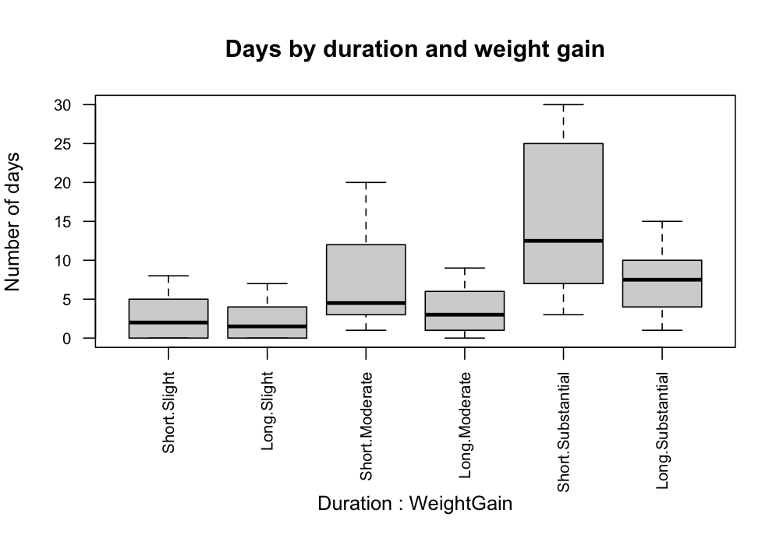
The boxplot of days by duration and weight gain demonstrates evident heteroscedasticity; the "Short.Substantial" group shows the highest median and greatest variability, while "Slight" weight gain groups maintain consistently low, compact distributions.
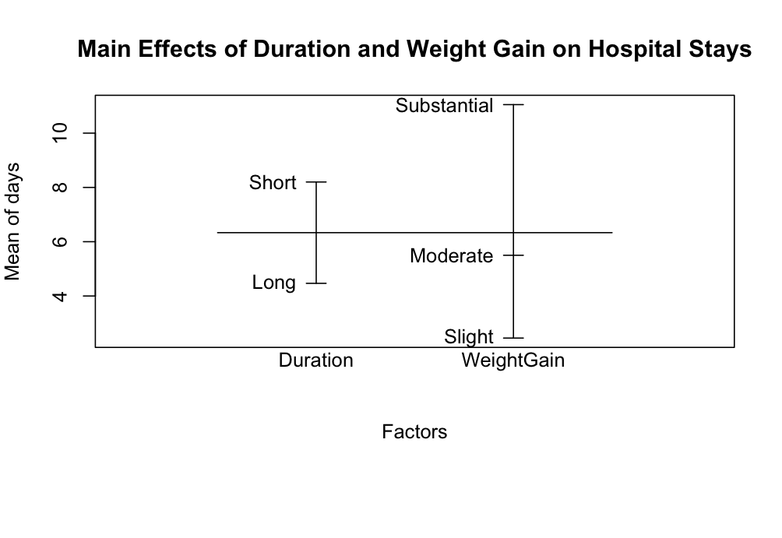
The main effects plot confirms the independent impact of both factors: hospitalization increases significantly with weight gain and is generally higher for the "Short" treatment duration. Notably, the vertical error bars expand considerably for the "Substantial" weight gain level compared to the "Slight" and "Moderate" levels. This visual trend aligns with the standard deviation data, illustrating that as weight gain increases, the data becomes more dispersed and outcomes become less predictable.
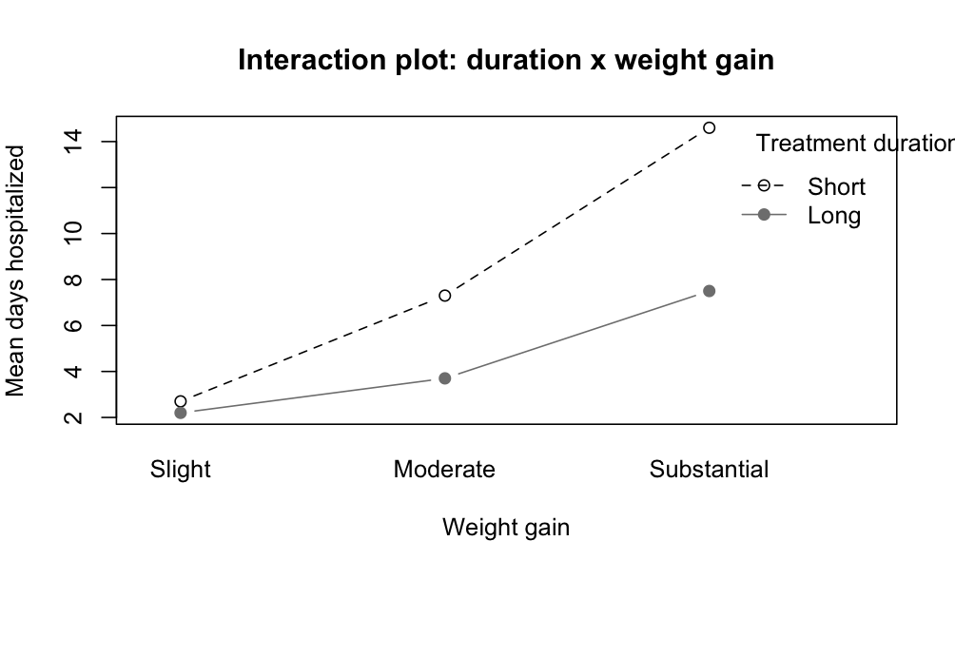
The interaction plot indicates that treatment duration moderates the relationship between weight gain and hospital stay. While "Slight" weight gain results in nearly identical outcomes regardless of treatment length, a sharp divergence occurs at the "Substantial" level. Here, the "Short" treatment mean exceeds 14 days, whereas the "Long" treatment mean remains near 7.5 days. This interaction suggests that the longer treatment protocol may mitigate the extended hospital stays typically driven by high weight gain.

